**EWQ Account _Bug report**

URl: https: <http://admin-qa1.eees.fi/>

User Name: kalam@gmail.comPassword:

**User Not able to Delete Privileges in Role:**

When User trying to delete an existing privilege in roles, user able to receive an un expected err message

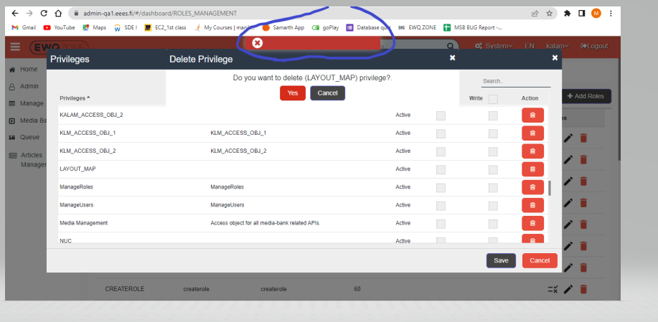

**User unable to delete in API Key:**

When User truing to delete an Existing Api key, user receives an Error message after click on delete option**.**

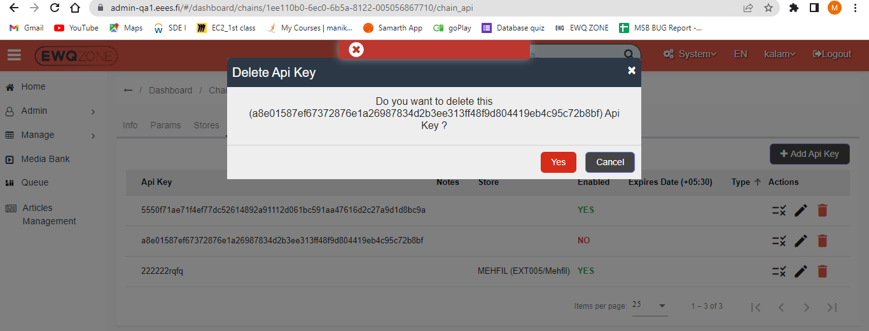

**User Unable to search in Api key Privileges page**

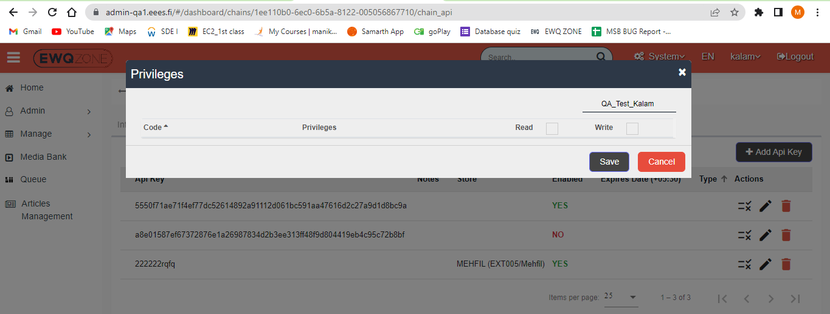

**User Created New Objects in specific store, once user click on edit symbol to update user unable to previous Chain and Store details:**

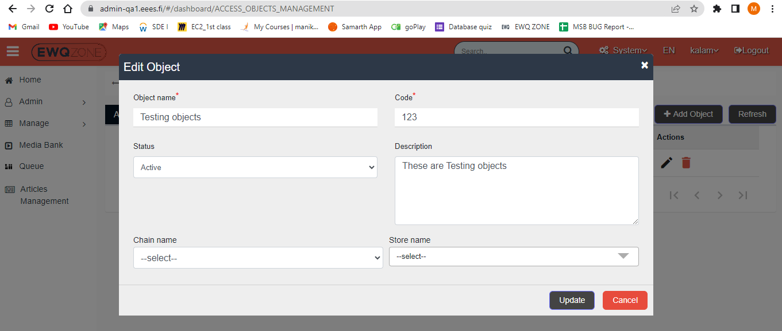

**User Unable to delete Access objects Once created:**

User receives an error message while trying to delete an access_objects

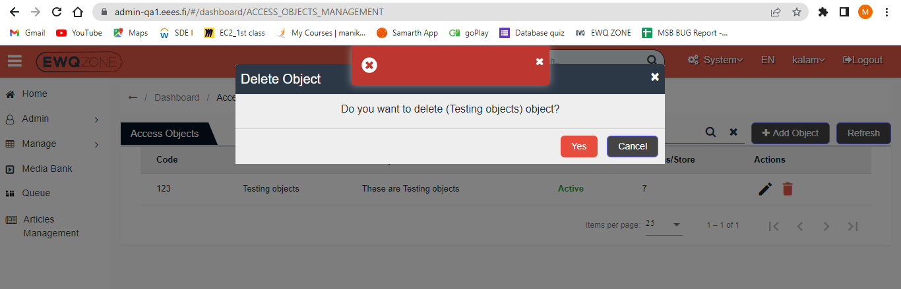

**User unable to refresh Access object page:**

Refresh button is un responsive

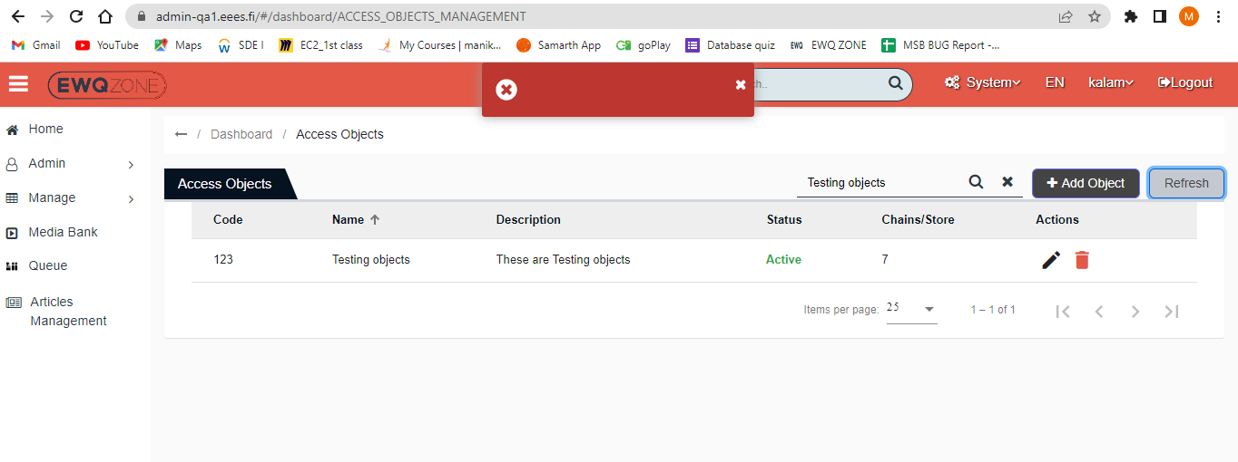

**User able to see an Unexpected Error Message, when click on Access object update button:**

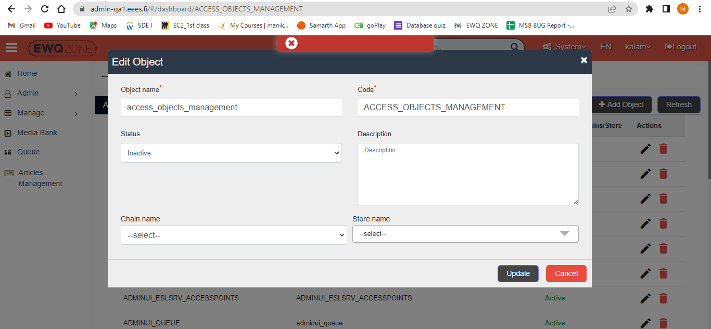

**User Unable to Edit article in Article management:**

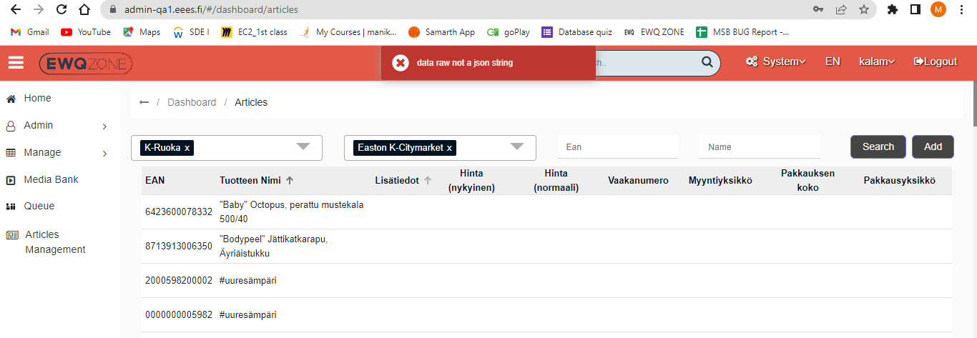

**In Display layout group List, user unable to delete an Layout group:**

